Unified Modelling Language (UML) Based Design

Amartya Mandal

19CS10009

Use Case Diagram

The Use Case Diagram for the Railway Reservation/Booking System is shown here.

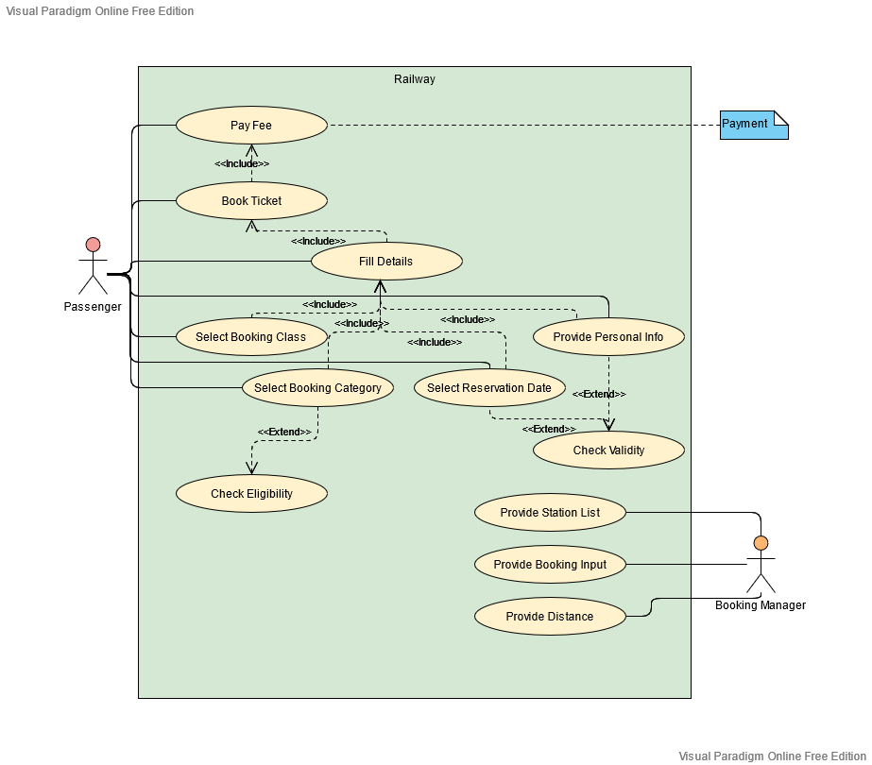

Fig. Use Case Diagram

Class Diagram

The Class Diagram for the Railway Reservation/Booking System is shown here.

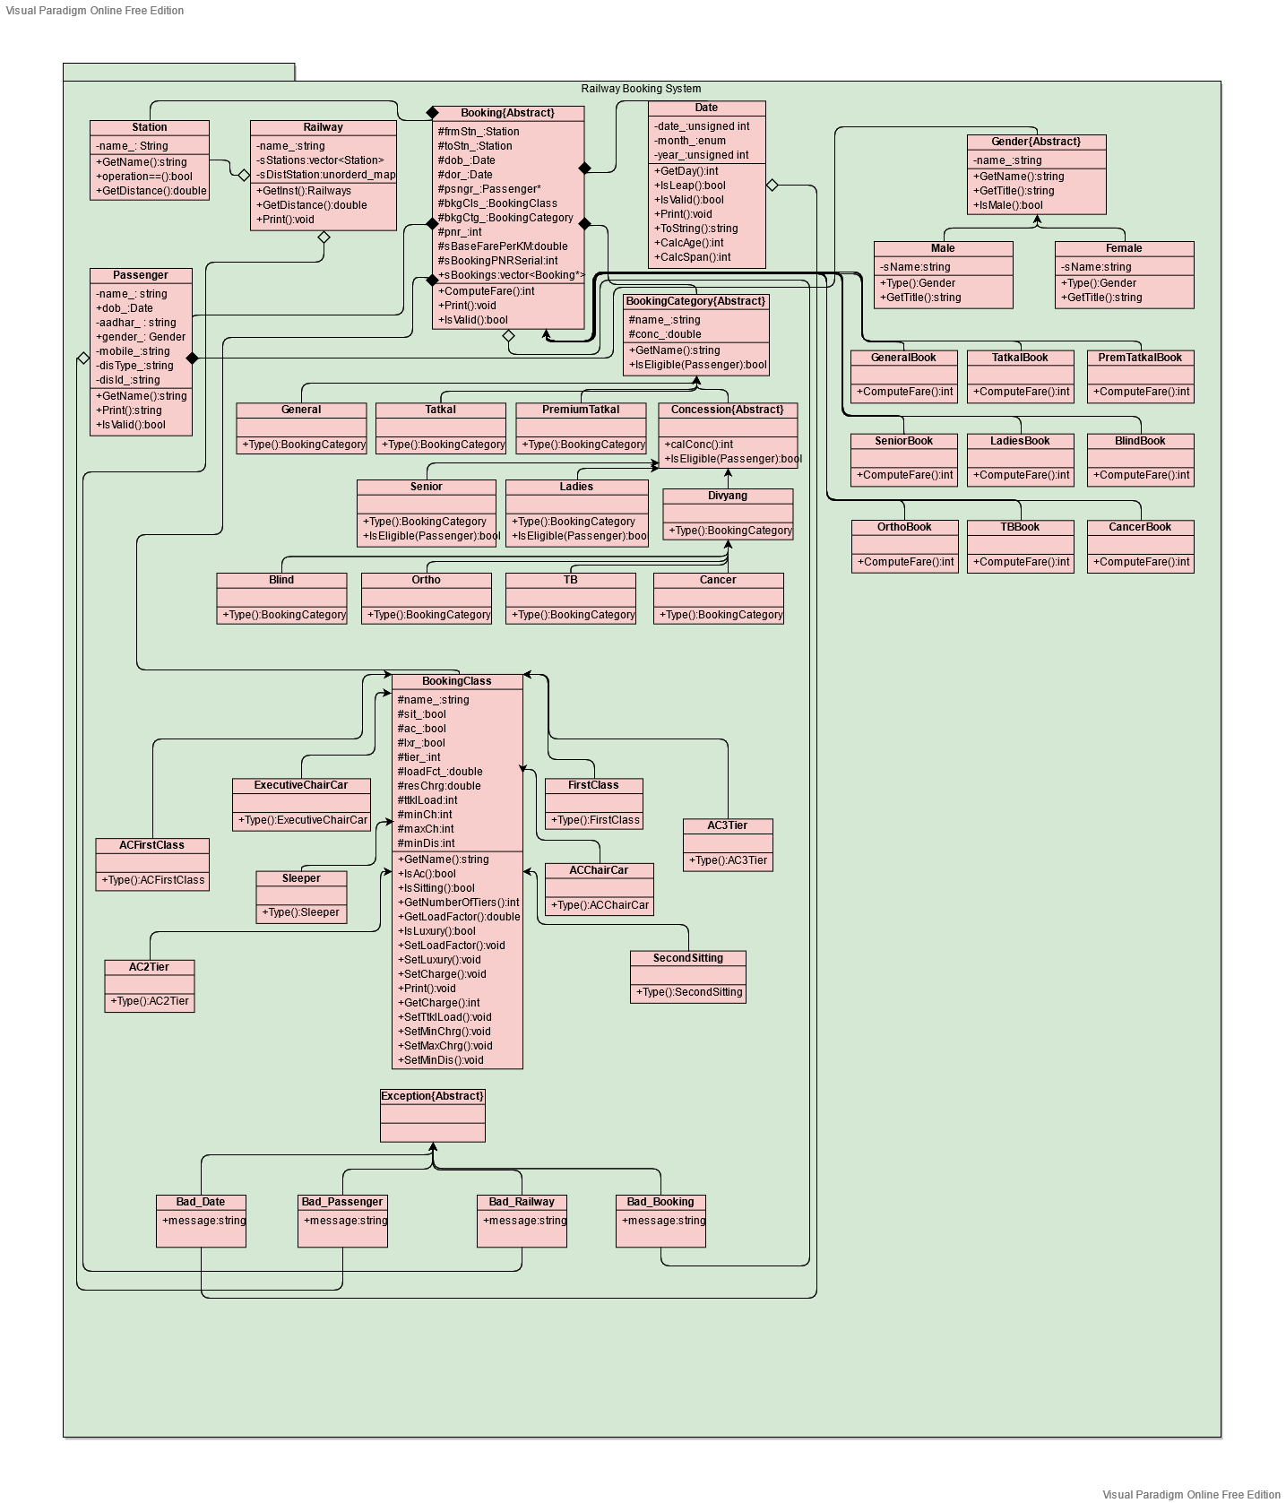

Fig. Class Diagram

Sequence Diagram

The Sequence Diagram for the Railway Reservation/Booking System is shown here.

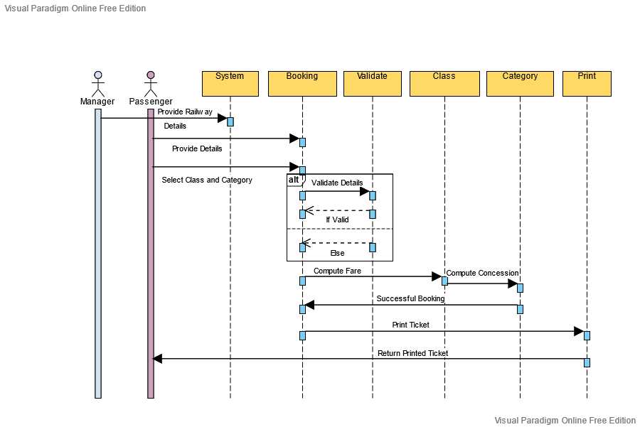

Fig. Sequence Diagram

Activity Diagram

The Activity Diagram for the Railway Reservation/Booking System is shown here.

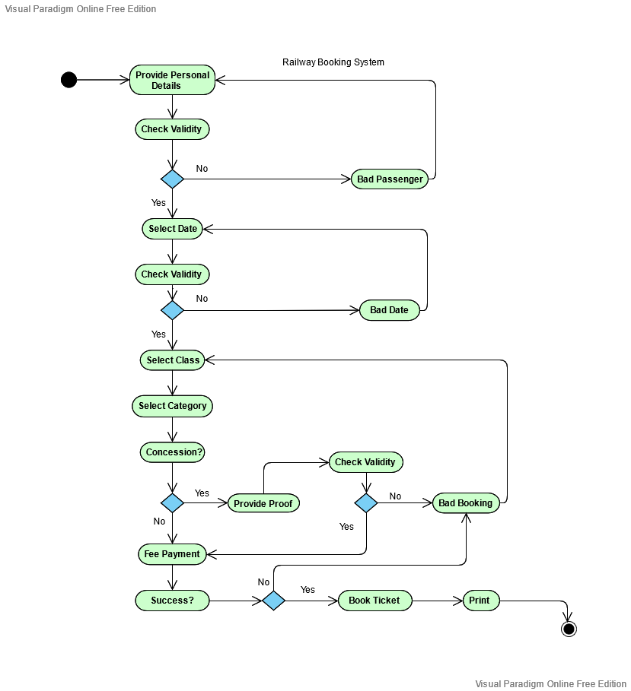

Fig. Activity Diagram

State Machine Diagram

The State Machine Diagram for the Railway Reservation/Booking System is shown here.

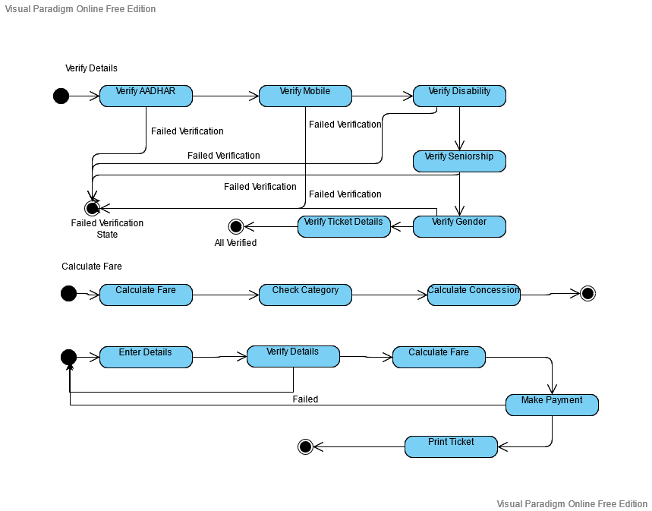

Fig. State Machine Diagram

Communication Diagram

The Communication Diagram for the Railway Reservation/Booking System is shown here. 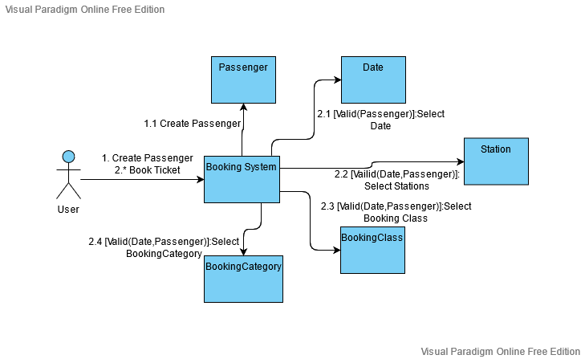

Fig. Communication Diagram